**Personal information**

My name is Matthew and I am 21, I am an online student at RMIT(**Student no. s3950819).** My student email is [**s3950819@student.rmit.edu.au**](mailto:s3950819@student.rmit.edu.au). 

I live in the regional part of South Australia on the Yorke peninsula. I have lived in Australia all my life and I have never left! One day I hope to explore other countries as living in one place for all your life isn’t something I am interested in.

I moved to the Yorke peninsula in 2016 for a change of pace as my dad became unwell. I am a bit of a nerd, I have been playing games online and singleplayer for all my life and I have a very nerdy father and brother. They both got me into gaming and computers in general at a very young age. My very first game that I remember playing is Super Mario 64 on the Nintento 64.

I played sport all throughout my schooling (Soccer, Basketball and a bit of Football). I am an extreme animal lover. I believe animals are more than just pets. I have three cats and a dog. The three cats are mine. However, the dog is a family dog. I have had at least one animal at a time throughout my life and I wouldn't change a thing.

My interest in IT came from my Dad, as he worked in the IT industry all his working career. He started as a Telstra technician way back when they were first setting up mobile towers. As he has always been around computers, my interest definitely was inspired by him. However, my brother is also a large impact on that inspiration as well. He is the one that got me into gaming and thus further cemented my desire to work in the IT industry.

I chose to study at RMIT as this allowed a more broad approach to learning and since I live remotely, allowed me to study online! I hope to learn all about the IT industry as I can from this course. Allowing me to get my dream job!

**Ideal Job**

[**https://www.seek.com.au/job/56041869?type=promoted#sol=e3b4f831b400af527ad8ac538737c9114bd022fb**](https://www.seek.com.au/job/56041869?type=promoted#sol=e3b4f831b400af527ad8ac538737c9114bd022fb)

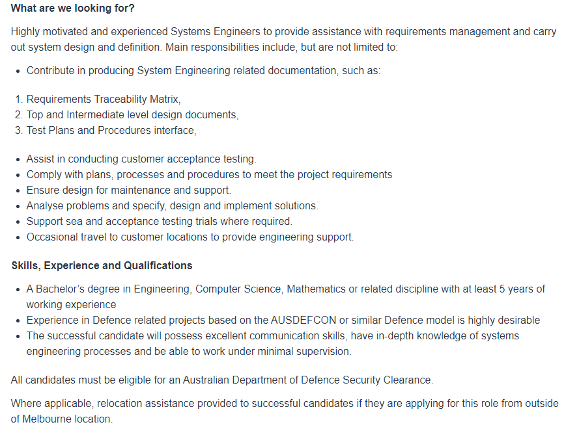

This job requires a lot of experience. However, this is something that has generally been what has inspired me to work in IT. Its not set in stone if this is what I’ll end up doing but it is at the moment, but could change by the time I finish this course.

This job would allow me to provide defence to cyber domains. Allowing me to develop systems that assist in safety which I think is pretty cool!

The skills required are pretty high, you generally need a degree in computer science or something along the lines of that. You need to be able to obtain the Australian Department of Defence Security Clearance for this job in particular.

I plan on finishing this course and then depending on if I am still set to do this job I would seek more qualifications to help me assist in gaining this type of employment. However, I would also seek a different job for more experience while I am continuing my study for Cyber security.

**Personal Profile:**

<https://www.16personalities.com/isfp-personality>

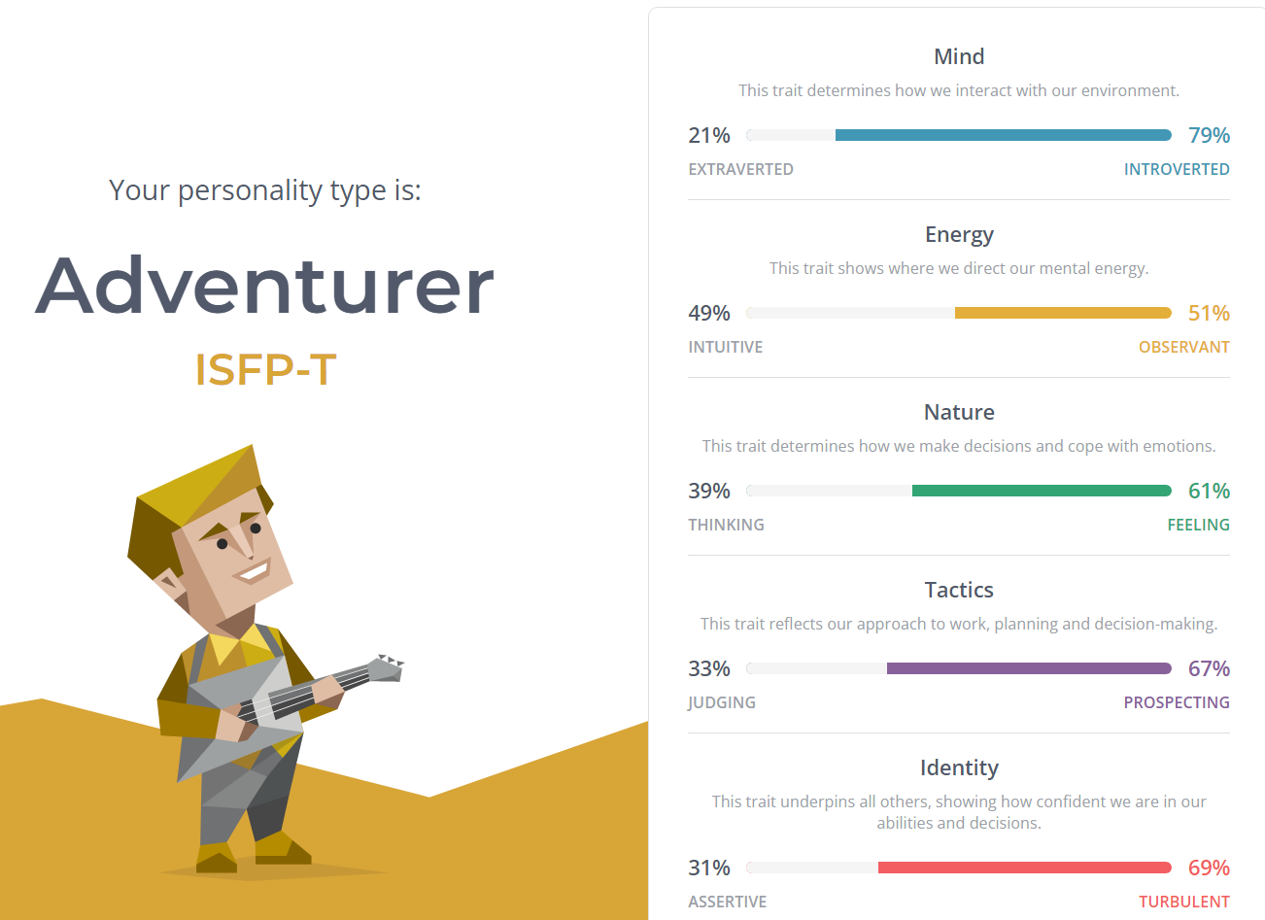

<https://vark-learn.com/the-vark-questionnaire/?p=results>

[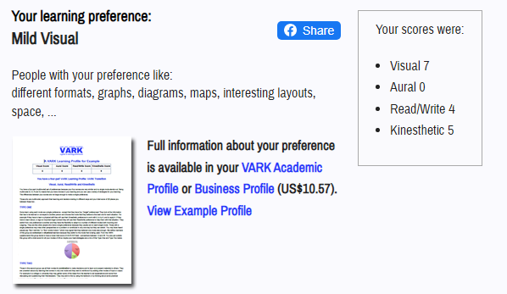](https://vark-learn.com/the-vark-questionnaire/?p=results)

<https://www.truity.com/test-results/bigfive/17315/28997534>

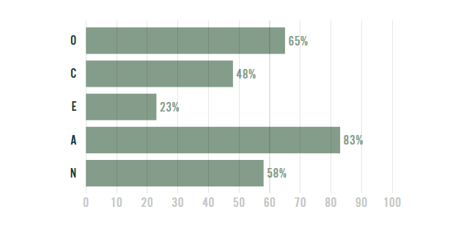

These results would influence my behaviour in a team as I am quite a shy person. Allowing other people ideas over my own. I respect other people more than myself. However, when given the chance I am able to give my personal input in what I believe the team should be doing.

When forming a team I do prefer to be lead over leading, so having a leader within a group environment is a must for me. I am quite happy to be told what to do with little resistance unless the decision is something I strongly disagree with.

**IT project idea**

My project idea allows local businesses to set up delivery in regional areas, by using an app and website to allow big or small businesses to get their name out there and deliver some good products to customers as some old or young customers don’t have time or are unable to interact with a smaller store personally.

In the Regional area that I live there are no delivery options for small businesses. This makes getting things kind of difficult, when sometimes you just want it delivered to your house. That being Take-away, groceries, or even small items from stores within towns. The closest service we have to deliver over here (not including the post), is Deliveroo. However, that is only active in the biggest town, about an hour and a half away from me. They don’t deliver outside of the town. My idea would be more inclusive and not just do Take-Away, but anything that someone would want delivered.

My idea would be called ***Rdelivery.*** However, that isn’t set in stone and is more of just a placeholder. The website of this service would be mainly for businesses, small or large to sign up to the service. However, even home businesses would be approved. Age wouldn’t necessarily be a factor but people under the age of 18 would need parental approval. We wouldn’t want to stop young entrepreneurs from their dreams. This would allow even the really small start-up businesses to still get going. The website wouldn’t just be for signing up to the service though, this is also where we would review driver applications. To improve local jobs we would hire local drivers to deliver products. Drivers would have to have their cars inspected and their backgrounds looked at just like other delivery companies and this ensures the safety of not only the driver, product, and customer but also helps us legally. However, why just limit the website to that? It would also be an idea to set-up a store like a user-interface. This would allow people to view all connected stores and would allow ease of access if they didn’t have the app.

The app would be more focused on telling the customer who the driver is, by showing their profile (with information approved by the driver), and estimated delivery time. We would aim to deliver bigger products on the same day but this would depend on the number of drivers we have and customers, so when we are in high demand wait time may be 1 - 2 days. Smaller products such as food would have their own category and would have a hopeful wait time of 15-30 minutes. The app would also have its own store section as the phone app wouldn’t be very user-friendly if it didn’t. This would allow people to order anywhere, even if they weren’t home. Each store would have its own website embedded within the app so that when you click the store that you want to browse it brings up all their products in a timely and convenient manner. The app would also have a rating feature to allow us to gather feedback on our drivers and store products. This would include delivery time and overall friendliness of the service. We want to be able to gather customer complaints with relative ease as this would allow us to act quickly when required.

To develop the website we would need a tool to help assist in this. A software program that could be used is Adobe XD. This tool is user-friendly in web design and would allow ease of creativity when it comes to website development. There is a free or paid option. Since Adobe XD is owned by Adobe it runs extremely well with other Adobe programs which allows for even easier integration if required when creating this website.

For the app I could use the tool Appery.io, this tool is purely for phone app (IOS or Android) development. It has a low-code requirement allowing new or old programmers ease of access. Although it has a low-code requirement, it allows you to write source code editing which would be very useful when developing an app of this size and structure.

Although the programs I listed to assist with the website are just baselines (Adobe XD, and Appery.io), I have never used them personally so whether or not they will do the things required, I wouldn’t know until I have tested them. However, the reviews and summaries of the development programs themselves are promising and are extremely well reviewed by users. I do believe finding the skills required to undertake such a delivery service will be challenging but a worthwhile endeavour. There are a lot of development programs out there that would help assist in the app and website of this service.

If the project gained some traction this would allow big and small businesses to thrive in the regional environment regardless of where they are. This would allow businesses to also get their name out there as we would have their website within the app and our website itself this would solve the issue of the lack of delivery options we have in the regional districts.

Reference list

NERIS Analytics Limited (2011). *16 Personalities*. [online] 16personalities.com. Available at: <https://www.16personalities.com/> [Accessed 18 Mar. 2022].

Truity. (n.d.). *The Big Five Personality Test*. [online] Available at: <https://www.truity.com/test-results/bigfive/17315/28997534> [Accessed 18 Mar. 2022].

VARK (2020). *VARK Questionnaire*. [online] VARK - A Guide to Learning Preferences. Available at: <https://vark-learn.com/the-vark-questionnaire/?p=results> [Accessed 18 Mar. 2022].

W3Schools (2018). *HTML Tutorial*. [online] W3schools.com. Available at: <https://www.w3schools.com/html/> [Accessed 18 Mar. 2022].